ALBANY ADULT RIDING CLUB
August 2021
Newsletter

August Rally – Sunday 29th August

HAVE A GO DRESSAGE & ARENA ETIQUITTE – $5 per rider 9:30 am to 12 noon
We are commencing the day with a session on dressage etiquette in the indoor arena. You then have the option of doing a test or two or three (time permitting).
The etiquette information session is so we can all learn how to correctly behave in an arena before and after dressage tests. Penny will advise us in all the what we can do and what we shouldn’t. This is also a chance to give your horse a look in the indoor prior to your test.
Tests available are Prelim, Prep and Novice. These will be emailed closer to the rally. It is essential you book in for this rally and let us know prior to the rally how many you would like to ride (this is of course depending on number of riders). Your tests will be given back to you for comparing to previous tests and learning what you need to work on. Tests can be called, ridden with walker or lead line if preferred. Plaiting is not necessary.
Tests will be emailed out closer to the rally.

LUNCH – $5 Toasties and beverage. 12 to 1pm
Please remember to book in so we know how many we are catering for.

Future Rallies

We have some great rallies planned for our rallies for this half of the year. In September we are having our Grand Prix. Get your Halloween costumes out for our Halloween theme day at our October rally. We will be ending our year with Pairs Dressage in November, followed by Orienteering/Fun day. At every rally we will be running a confidence and/or free activity. These will be able to be done at a pace you feel confident at and can be done mounted or unmounted.
If there is something you would love to do at our rallies, please do not hesitate to let the committee know as we are here to help you.

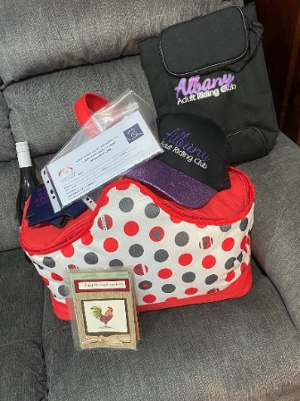
Raffle

1st Prize – 2022 AARC Membership Winner – Sandra Frid
We had lots of winners of our prizes – Wine – Janine, AARC Cap – Camilla, Special T Vouchers – Penny & Petra, Horse Hemp Co products – Tisa, Blu-ray – Fee, Wine Cooler – Maggie, Bags by Tisa – Penny & Sarah, Picnic Bag – Sarah, Slow Feeder – Maggie, Fly Mask – Fee, Stubby Holders & Cards – Tisa & Liz.

Massive Thanks
Thank you to all prize providers –
Kelly from Hemp Horse Co. (Check out their website Horsehempco.com.au) – supplier of hemp horse supplements (powder, pallets & oil) as well as cream.
Tracy from SpecialT Animal Health (Check them out on Facebook – (SpecialTAnimalHealth) – SpecialT provide a wide range of therapies to keep your equine functioning at their best. Big thanks to Tracy also for her informative demo, it was great.
As well as some of our committee members for their prizes- Amanda Owens, Tisa Crocker, Penny Slebos and Fiona Holden.

Uniform
Our uniform colours are black and purple. We have a range of polo shirts, long sleeve shirts, vests and jackets available. All of these can also have your name embroidered on for an extra $5.50. I have attached information on the jackets available. We also have available some old uniform available including some SunSmart L/S shirts. Uniform order form can be found on the website.

Housekeeping
Please ensure that your yards are clean and closed prior to leaving the rally. Also remember to check in using the Q Code up at the clubrooms at each rally. Camping is available at the AEC grounds but must be booked and paid for prior via the Albany Equestrian Centre.
Lesson Bookings
Process for booking a lesson –
- Email AARC – advise of instructor/coach required and if requesting lunch (as well as any dietary requirements). if you do have a preference for start time (9, 10 or 11am) please let us know and we will try to accommodate you if possible. Please note that you may not get a response until closer to the rally.
- Pay amount into our bank account (BSB 086519 Account 414429819) leave your name as reference.
- Wait for AARC to forward you rally lesson schedule on the Friday or Saturday prior to rally.
Cheers
Fee Holden

